VISIONING LISTENING FINDINGS

Rumple Memorial Presbyterian Church

Executive Summary – October 2025

armstrongmcguire.com   
PO Box 6485, Raleigh, NC 27628 | 919.390.1925

Table of Contents

Assessment Methodology 3

Landscape Scan 6

Organizational Assessment Detail 8

Conclusion & Recommendations 28

# Assessment Methodology

## Background

Rumple Memorial Presbyterian Church has embarked on a visioning process to clarify its mission, values, and priorities for the coming years. This process comes at a meaningful moment in the life of the church—a time of growth and change, but also reflection and discernment.

For the past several years Rumple has experienced a season of growth. They have had consistent pastoral leadership, engaging worship, a commitment to congregational care, and a strong outreach ministry. They were poised to respond to the effects of hurricane Helene in meaningful ways which deepened Rumple’s calling to outreach and presented the opportunity for Rumple to directly respond to community needs.

Rumple’s last season of goal setting was in 2018. From that discernment came many goals that were centered on Rumple’s newly adopted Cornerstones: **Worship, Mission, Education,** and **Community**. An Implementation Team was formed to provide leadership and determine resources needed to live into the plan. Expanded staffing and a capital campaign were the result of responding to the top priorities from the original goals:

* Continue/Expand Visiting Scholar (Education)
* Expand Visitation Ministry in Pastoral Care (Community)
* Direct Educational Programs to Young Families (Education/Children/Youth team)
* Respond Directly and Proactively to Community Needs (Missions)
* Develop Connections with Organizations and Potential Partners (Missions)

Rumple is nearing completion of its final strategic objectives, with the construction of Fellowship Hall marking the last phase. To ensure that comprehensive operational plans were established for the new Fellowship Hall—especially given the expanded opportunities for community engagement and use by external mission teams—Rumple initiated a new visioning phase to incorporate community input into the final planning process.

Guided by a desire to listen deeply to the congregation and community, Rumple engaged Armstrong McGuire to facilitate a series of listening sessions, interviews, and surveys to understand where the church is thriving, where challenges exist, and where God may be calling Rumple next.

The purpose of this listening phase was simple yet vital: to hear from those who love and lead the church, gather their collective wisdom, and surface key themes that will shape the next season of strategic planning.

#### Methodology

The approach for this assessment was to evaluate the key elements that define organizational capacity and sustainability, with focus on the essential pillars of organizational capacity and effectiveness.

The findings shared in this report are based upon the aggregate feedback and analysis conducted during the listening process. It is important to note that Armstrong McGuire did not complete an in-depth review of specific systems, processes, policies, or reports as part of this evaluation. The findings in this assessment come directly from participating stakeholders and our high-level review of materials shared.

A Vision Committee was established to provide leadership and support for the process. Members included Kathy Beach, Bob Baker, Kim Kincaid, Sonya Long, Louise Moore, Kim Price, Stacey Rex, and Gary E. Scott with Jenny Apker and Cullie Tarleton serving as Co-Chairs.

## Stakeholder Input

A total of 127 individual interviews, focus groups, and listening sessions were conducted, supplemented by a survey that garnered responses from 126 church members. This is a high response and shows strong engagement by membership and community. This diverse mix of qualitative and quantitative data collection methods provided a robust foundation for understanding the congregation's needs, perceptions, and aspirations.

**Listening Interviews and Sessions:**

* Staff: 7 interviews
* Membership: 7 interviews
* Committee Survey Responses: 7
* Listening Sessions: 82 attendees
* Interfaith Group:10 attendees
* Community Partners: 14 attendees

**Listening Survey:**

* Response: 126
* Connection to Rumple:

|  |  |  |
| --- | --- | --- |
| Church Member | 96 | 77% |
| Affiliate Member | 11 | 9% |
| Church Committee/Ministry Leader | 32 | 26% |
| Former Committee/Ministry Leader | 13 | 10% |
| Community Partner | 3 | 2% |
| Visitor | 9 | 7% |
| Pastor/Staff | 3 | 2% |

## Survey Data Representation

In some cases, survey percentages have been rounded and figures may not equal 100%. As all questions were not required, the number of respondents to a specific question may be less than the number of respondents to the survey.

Throughout this report you will see open ended feedback and data points based on combined responses from interviews, listening sessions, and survey. Ratings were requested on a 5-point scale with 5 being the positive viewpoint. Average ratings above 3.5 are considered positive.

Charts within this report contain the breakdown of the weighted average so you can see the quantity of those who gave the individual rating.

# Listening Findings

## Church Membership Perceptions

As part of its strategic visioning process, Rumple undertook a congregation-wide listening effort designed to surface insights, perspectives, and priorities from those who know the church best—its members, staff, and leaders. This process, led by Armstrong McGuire, included more than 120 listening touchpoints: interviews with staff and engaged members, affiliate members, community leaders, and multiple listening sessions. A comprehensive survey rounded out the effort, garnering responses from 126 individuals. The goal was to understand the current experience of church life and how the congregation envisions its future.

##### Strengths and Core Identity

The listening process reaffirmed that Rumple is a warm, faithful, and mission-minded congregation. Members consistently described Rumple as a welcoming church with strong preaching, inspiring music, and an authentic sense of community.

Pastor Kathy’s leadership and preaching were repeatedly named as central strengths—anchoring worship with theological depth, warmth, and relevance. Music and worship arts also play a vital role in Rumple’s worship life, offering both beauty and inspiration that deepen connection to God. The physical beauty of the church, campus, and location is frequently mentioned as a strength, including the sanctuary, frescos, and the Gathering Space.

Members expressed pride in Rumple’s long-standing reputation for service and outreach, with strong ties to local missions such as Blowing Rock Cares, Hospitality House, Habitat for Humanity, and other community organizations. Rumple is recognized as outward-facing, a servant congregation that contributes meaningfully to the wider community.

Since the creation of Rumple’s Cornerstone through the last strategic planning process, members identified that Rumple is actively living into its Cornerstones. These identity points represent the mission and values of the Rumple community.

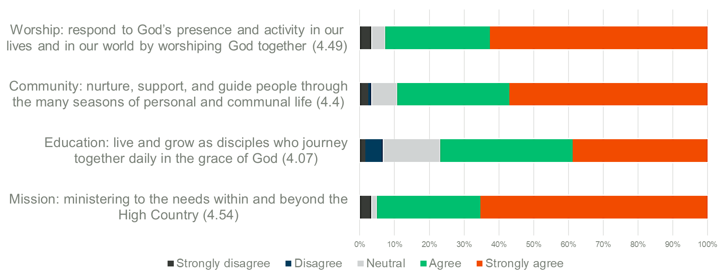

##### Opportunities for Growth

Several consistent themes emerged around opportunities to strengthen Rumple’s ministry in the coming years:

* **Attracting younger families and children.** Members see a need to deepen Rumple’s focus on children, youth, and families through programming, staffing, and intergenerational connection.
* **Building relationships and belonging.** Congregants long for more ways to connect—through fellowship dinners, small groups, and shared experiences that help members know one another more deeply. They also understand some of these opportunities will reappear when the Fellowship Hall is completed.
* **Enhancing staffing and sustainability.** The congregation recognizes the exceptional commitment of Rumple’s staff and the strain created by turnover and growth. As the new building comes online, staffing capacity, support roles, and facility management will require thoughtful planning and expansion.
* **Spiritual formation and education.** Many expressed a desire for deeper Bible study, consistent learning opportunities, and small groups that nurture spiritual growth beyond Sunday worship.

##### Worship Reflections

Worship remains the heart of Rumple. Sermons, music, and lay participation were frequently named as the greatest strengths. Members value Rumple’s theological grounding, joyful spirit, and inclusivity. It was evident that traditional worship represents a core strength and requires no modifications at this time.

At the same time, there is also interest in offering a worship experience that welcomes families with young children who may feel uncomfortable in a traditional historic setting. Once the new Fellowship Hall is finished, there is hope to create an alternative worship service there—possibly featuring a simulcast or a modified traditional style. Improved sound and online quality were also noted as practical needs.

##### Organizational Health and Leadership

Overall perceptions of staff and leadership were highly positive. Pastor Kathy and the pastoral team were described as caring, approachable, and spiritually grounded. Yet there is recognition that Rumple’s growing complexity—new facilities, expanded ministries, and diverse communication needs—will require additional support staff and clear role definition to prevent burnout and maintain alignment.

Most members express deep trust in Rumple’s leadership and a sense of personal responsibility to give. Faithful stewardship and the biblical call to tithe were cited as primary motivations. Members also encouraged continued transparency in financial reporting and decision-making, especially as the church enters a new season of growth and opportunity.

##### Future Direction Priorities

During listening, members were asked “where Rumple should focus in this next season,” and “where is Rumple being called.” There was great consistency in the response and that was affirmed by the survey.

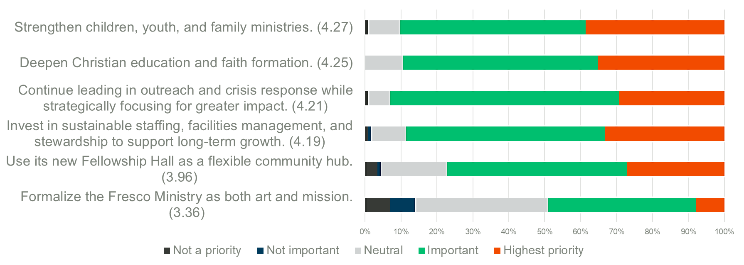

A big part of the conversation was ensuring that Rumple was operationally ready when the campus capital improvement are completed, that staffing is secured to help manage the growth, and that the larger community was consulted so that their needs are also included in the final product.

Two focus groups were included in the listening process, an interfaith group and a community partner group comprised of school counselors, nonprofits, the Town Manager, police, health workers, etc. The following represents the community needs and gaps identified by these groups.

* **Mental and Behavioral Health:** Depression, addiction, and mental health needs are widespread and continue to rise. Access to care is limited by insurance barriers and availability of providers. Social isolation compounds these challenges, especially among vulnerable populations.
* **Housing and Homelessness:** Affordablehousing is scarce, making it difficult for families, workers, and seniors to remain in the community. Homelessness is a growing issue, with reports that other counties drop off people in Watauga County, straining local resources.
* **Transportation Barriers:** Lack of reliable, affordable transportation prevents people from accessing jobs, schools, healthcare, childcare, and social support. Rural geography intensifies this gap.
* **Food Insecurity:** Food insecurity remains a persistent problem, particularly for lower-income families and those affected by seasonal employment or weather disruptions.
* **Education and Childcare:** Daycare and preschool access is both limited and unaffordable for many families. Broader education challenges impact children’s stability and long-term success. Parents need more support systems to help their children thrive.
* **Community Stability and Resilience:** Weather disruptions (snow, storms, e.g., “lost a month to Helen”) expose fragility in community infrastructure, schooling, and family routines. The need for stronger community connectors and coordinated responses is clear.

Numerous suggestions were generated through these discussions and listening sessions with church members regarding the most effective ways to leverage Rumple's resources, facilities, and strengths to address community needs. Some of those ideas include:

1. **Youth, Children, & Families**

* Expand after school program, club space for middle school.
* Mother’s morning out program.
* Space for teens to connect and play (Friday night or afterschool). Needs to be accessible and include a low-sensory area.

**2. Congregational Fellowship & Faith Formation**

* Host Wednesday night suppers, church-wide meals, holiday gatherings, and special events.
* Create spaces for intergenerational connection (e.g., buddy programs, small groups).
* Strengthen Christian education and faith formation opportunities for all ages.
* Use facilities to bring Rumple together as one family in Christ.

**3. Community Hub & Outreach**

* Share space with larger community, nonprofits, civic groups, and other congregations.
* Host 12-step programs, support groups, and community events.
* Community hub: block parties, ice cream socials, square dance/Latin dancing–social events to break down barriers.
* Support mission and youth groups staying on campus.
* Provide respite care opportunities (for caregivers, memory care, seniors).
* Educate congregation and community about available community resources.

**4. Preparedness & Crisis Response**

* Position Rumple as a reliable anchor during natural disasters and community crises.
* Equip fellowship hall with a generator, showers, kitchen, and storage to serve as a distribution center.
* Consider “Room in the Inn”/warming center models.

# Conclusion

The listening process affirms that Rumple is a church with strong roots and open hands—rooted in faith, relationships, and service, yet open to new ways of worshiping, connecting, and growing together. The congregation’s voice is united in its gratitude for meaningful worship, caring relationships, and a deep sense of God’s presence within this community.

At the same time, there is an eagerness to look ahead—to strengthen the foundation for the next generation, to foster connection among members, and to use Rumple’s gifts and new spaces to serve the broader community.

This visioning process offers the opportunity to build on the church’s enduring cornerstones—worship, community, education, and mission—and to discern, together, how God is calling Rumple Memorial Presbyterian Church to live them out in fresh and faithful ways.

On behalf of the Armstrong McGuire team, thank you for the opportunity to collect and analyze your stakeholder input.